**Semester 2 Examination 2016**

**Question/answer booklet**

Circle your teacher’s initials

JIB MAW MPC SWA VMU

**Mathematics Methods**

**Units 3 & 4**

Section One

**(Calculator Free)**

**Your name**: _________________________________

**Time allowed for this section**

52

Reading time before commencing work: five minutes

Working time for paper: fifty minutes

**Materials required/recommended for this section**

***To be provided by the supervisor***

This Question/Answer Booklet

Formula Sheet

***To be provided by the candidate***

Standard items:pens (blue/black preferred), pencils (including coloured), sharpener, correction tape/fluid, eraser, ruler, highlighters

Special items: nil.

**Important note to candidates**

No other items may be taken into the examination room. It is **your** responsibility to ensure that you do not have any unauthorised notes or other items of a non-personal nature in the examination room. If you have any unauthorised material with you, hand it to the supervisor **before** reading any further.

**Structure of this paper**

|  |  |  |  |  |  |
| --- | --- | --- | --- | --- | --- |
| Section | Number of questions available | Number of questions to be answered | Working time (minutes) | Marks available | Percentage of exam |
| **Section One:**  **Calculator-free** | **8** | **8** | **50** | **52** | **35** |
| Section Two:  Calculator-assumed | 12 | 12 | 100 | 95 | 65 |
|  |  |  |  | **Total** | 100 |

**Instructions to candidates**

1. The rules for the conduct of Western Australian external examinations are detailed in the *Year 12 Information Handbook 2016.* Sitting this examination implies that you agree to abide by these rules.

2. Write your answers in the spaces provided in this Question/Answer Booklet. Spare pages are included at the end of this booklet. They can be used for planning your responses and/or as additional space if required to continue an answer.

• Planning: If you use the spare pages for planning, indicate this clearly at the top of

the page.

• Continuing an answer: If you need to use the space to continue an answer, indicate in the original answer space where the answer is continued, i.e. give the page number.

Fill in the number of the question(s) that you are continuing to answer at the top of the page.

3. **Show all your working clearly.** Your working should be in sufficient detail to allow your

answers to be checked readily and for marks to be awarded for reasoning. Incorrect

answers given without supporting reasoning cannot be allocated any marks. For any

question or part question worth more than two marks, valid working or justification is

required to receive full marks. If you repeat an answer to any question, ensure that you

cancel the answer you do not wish to have marked.

4. It is recommended that you **do not use pencil**, except in diagrams.

5. The Formula Sheet is **not** handed in with your Question/Answer Booklet.

**Question 1 (8 marks)**

Differentiate (simplifying and leaving answers with positive indices where appropriate):

a) . (2 marks)

b) . Factorise your answer. (3 marks)

c)  (3 marks)

**Question 2 (5 marks)**

a) Determine . (2 marks)

b) Hence, or otherwise, evaluate exactly . (3 marks)

**Question 3 (7 marks)**

Differentiate the following with respect to , simplifying your answers.

a)  (2 marks)

b)  (2 marks)

c)  (3 marks)

**Question 4 (8 marks)**

A biased die with six faces is rolled. The discrete random variable *X* represents the score on the uppermost face. The probability distribution of *X* is shown in the table below.

|  |  |  |  |  |  |  |
| --- | --- | --- | --- | --- | --- | --- |
| *x* | 1 | 2 | 3 | 4 | 5 | 6 |
|  | *a* | *a* | *a* | *b* | *b* | 0.3 |

a) Given that E(X) = 4.2 find the value of *a* and the value of *b*. (5 marks)

b) If E(*X* 2) = 20.4, determine Var(Y) where . (3 marks)

**Question 5 (6 marks)**

A biased die with five faces is rolled. The discrete random variable D represents the score which is on the uppermost face.

The cumulative distribution function of D is shown in the table below.

|  |  |  |  |  |  |
| --- | --- | --- | --- | --- | --- |
| *d* | 1 | 2 | 3 | 4 | 5 |
|  |  |  | 3*k* | 4*k* | 5*k* |

a) Calculate the value of *k*. (1 mark)

b) Give the probability distribution of *D*. (3 marks)

This die is rolled twice and the two scores are added.

c) Calculate the probability that the sum of the two scores equals 3. (2 marks)

**Question 6 (5 marks)**

Given that and *,* express each of the following in terms of *x* and *y*.

a)  (1 mark)

b)  (1 mark)

c)  (3 marks)

**Question 7 (7 marks)**

a) Solve  giving your answer(s) exactly. (4 marks)

b) Express  in terms of  if . (3 marks)

**Question 8 (6 marks)**

Part of the graph of  is shown below. The areas of the bounded regions A and B are 9 and 5 square units respectively.

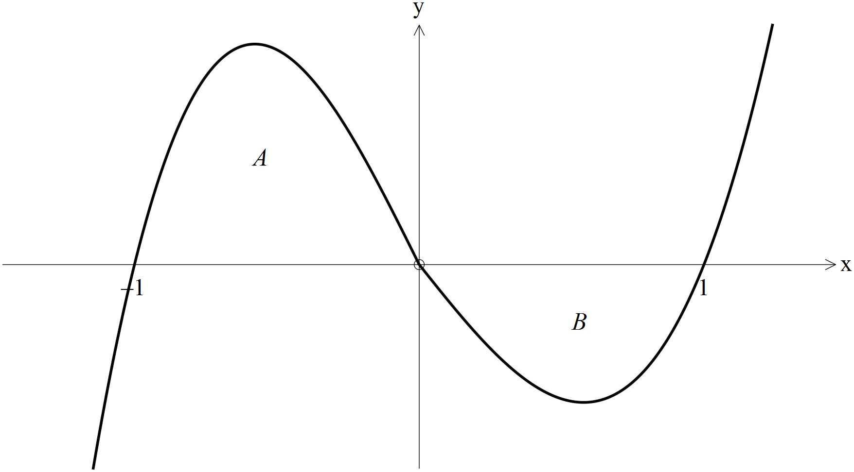

a) Evaluate  (2 marks)

b) Evaluate  (1 mark)

c) Evaluate  (3 marks)

**END OF SECTION ONE**

**Additional Working Space**

Question Number:____________

**Additional Working Space**

Question Number:____________